Module 2:
Using Data and Research to Improve Career and Technical Education Programs
Activity Handouts
Authors:
Marjorie Cohen
Steve Klein
Cherise Moore
Reviewers:
Pradeep Kotamraju, PhD
Linda Romano
Lyn Velle

Contents
Page
Activity 1: Opening Self-Reflection 1
Activity 2: Applying Research 2
Activity 3: Root Cause Analysis 3
Activity 4: Operational Planning 8
Activity 5: Study the Data 10
Activity 6: Closing Self-Reflection 12

Activity 1: Opening Self-Reflection
Purpose: This 5-minute exercise lays the groundwork for the activities included in this training module. It is intended to help focus your thinking about using data and research to improve programs and can help to identify a range of challenges perceived by different members of you team.
Directions: Think about a pressing career and technical education problem you face at your site.
- What is the problem you identified?
Blank area to fill in
- Why do you think the problem exists?
Blank area to fill in
- What types of data do you think you would need to address it?
Blank area to fill in

Activity 2: Applying Research
Purpose: This 10-minute exercise will help you practice how to find online CTE research studies that you can use to address a pressing problem at your site.
Directions: Refer to the pressing CTE problem at your site that you identified as part of Activity 1: Opening Self-Reflection.
- What is the problem you identified?
Blank area to fill in
- What key words can you use to describe it?
Blank area to fill in
- Determine and list a source you might consult to identify studies pertaining to your issue. Options identified in the module include:
  - Federal:
    - Perkins Collaborative Resource Network: https://cte.ed.gov/
  - Academic:
    - CTE Research Network: www.cteresearchnetwork.org/
  - Professional associations:
    - Advance CTE: https://www.careertech.org/resource-center
    - Association for Career & Technical Education: https://www.acteonline.org/publications/
  - Journals:
    - Association for Career and Technical Education Research: www.acteronline.org/
    - Journal of Career and Technical Education: hwww.journalcte.org/
    - Institute of Education Sciences: www.eric.ed.gov/
- Identify up to three studies that may help to answer your question. Note that you also should skim the study abstract to get a more nuanced understanding of the work.
Study 1: (title, link)
Blank area to fill in
Study 2: (title, link)
Blank area to fill in
Study 3: (title, link)
Blank area to fill in

Activity 3: Root Cause Analysis
Purpose: For this 15-minute exercise, you will use evidence and research to identify significant factors that influence student performance. Identifying these factors and underlying causes based on data and evidence can help you focus on the areas that will provide the greatest opportunities for change. This activity can be done individually to gain familiarity with the steps, but is designed to be worked through with a team.
Directions: Follow the steps below using the attached data and “fishbone” template:
- Review the sample performance data below (Table 1).
Table 1. Sample Performance Data
Nontraditional Completion Secondary (4S1)
 | Performance | Actual vs. Target | Met 90% of Target?
State performance target | 28% | — | —
Site performance | 22% | 79% | N
Gender
Male | 32% | 114% | Y
Female | 14% | 50% | N
Race/Ethnicity
Alaskan Native | 28% | 100% | Y
American Indian | 32% | 114% | Y
Asian | 20% | 71% | N
Black or African American | 14% | 50% | N
Hispanic or Latino | 26% | 93% | Y
Native Hawaiian or Pacific Islander | * | * | *
White | 20% | 71% | N
Two or more races | 27% | 96% | Y
Special Populations and Other
Individuals with disabilities | 21% | 75% | N
Economically disadvantaged | 22% | 79% | N
Limited English proficient | 26% | 93% | Y
Migrant status | 18% | 64% | N
Homeless individuals | 18% | 64% | N
Youth in foster care | * | * | *
Youth with parent in military | 27% | 96% | Y
*<10 students
- Please answer these questions about Table 1:
  - How is the site performing overall?
Blank area to fill in
  - Which populations need support?
Blank area to fill in
- Please review Exhibit 1 on page 6, for an example of a completed fishbone diagram. Based on your analysis of Table 1, write a problem in the box at the “head” of the fish below in Exhibit 2, the blank fishbone diagram, on page 7.
Blank area to fill in
- Based on evidence and research, identify major factors influencing this problem, and write them in the rectangular boxes in Exhibit 2. The diagram has four “ribs” with these boxes, but you may have fewer or more (add more if needed). Factors will vary depending on the problem. Examples could include students, families, systems and processes, curriculum, instructors, community supports, and so on.
Blank area to fill in
- For each factor identified, brainstorm causes. Write the causes next to the “ribs” for each box.
  - Generate as many as possible, writing the first thing that comes to your mind. The point of this exercise is to generate options, not to evaluate or sort them (yet).
  - Note: If this is done with a group, share brainstormed causes without discussing their validity, and make sure that everyone contributes.
- Using relevant data, evidence, and research related to the causes identified, analyze each identified cause to determine whether it is a root cause by asking:
  - Would the problem have occurred if the cause had not been present? __ Yes __ No
  - Would the problem reoccur if the cause were corrected? __ Yes __ No
If the answer to both questions is “no,” you have found a likely root cause.
- Cross off ideas that are not root causes.
  - Causes may be on a continuum, from lightly rooted (secondary) to deeply rooted (primary).
  - Think about primary versus secondary root causes, and focus on primary root causes.
- Identify one to three root causes that are within the realm of control of the school, and write them next to the appropriate “rib” of the fish. These will be the focus of your action planning.
Blank area to fill in

Perkins V Secondary Data Definitions
Participant: An individual who completes not less than one course in a CTE program or program of study of an eligible recipient.
Concentrator: A student served by an eligible recipient who has completed at least two courses in a single CTE program or program of study.
4S1: Nontraditional Program Concentration
The percentage of CTE concentrators in CTE programs and programs of study that lead to nontraditional fields. This means that a student gets counted under this indicator if individuals from their gender comprise less than 25% of the individuals employed in the related occupation or field of work.
Numerator: Number of CTE concentrators from the underrepresented gender group (males or females) who graduated in the reporting year from a CTE program that leads to employment in nontraditional fields.
Denominator: Number of CTE concentrators (males and females) who graduated in the reporting year from a CTE program that leads to employment in nontraditional fields.

Perkins V Postsecondary Data Definitions
Participant: An individual who completes not less than one course in a CTE program or program of study of an eligible recipient.
Concentrator: A student enrolled in an eligible recipient who has— ‘‘(i) earned at least 12 credits within a career and technical education program or program of study; or (ii) completed such a program if the program encompasses fewer than 12 credits or the equivalent in total.”
3P1: Nontraditional Program Concentration
The percentage of CTE concentrators in CTE programs and programs of study that lead to nontraditional fields. This means that a student gets counted under this indicator if individuals from their gender comprise less than 25% of the individuals employed in the related occupation or field of work.
Numerator: Number of CTE concentrators from the underrepresented gender group (males or females) in a CTE program that leads to employment in nontraditional fields who exited school in the reporting year.
Denominator: Number of CTE concentrators (males and females) in a CTE program that leads to employment in nontraditional fields who exited school in the reporting year.

Nontraditional fields: Individuals from their gender comprise less than 25% of the individuals employed in the related occupation or field of work (e.g., males in early childhood education or nursing and females in welding or construction).
Strengthening Career and Technical Education for the 21st Century Act (Public Law 115-224): https://www.congress.gov/115/plaws/publ224/PLAW-115publ224.pdf
Exhibit 1. Example of Completed Fishbone Diagram
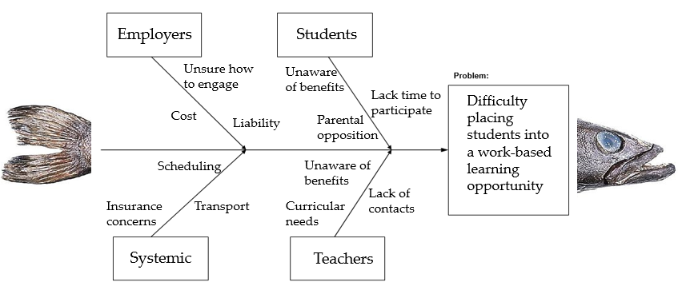

Exhibit 2. Blank Fishbone Diagram
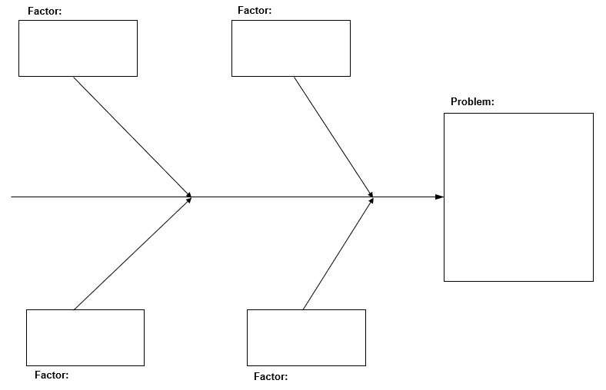

Activity 4: Operational Planning
Purpose: This exercise is to help you apply research-based evidence in a systemic way to solve the program challenges that you or your group identified. Ideally, the operational plan you develop will help you to incorporate rigorous research into targeted activities designed to address the performance gaps and programmatic challenges you identified. This activity can be done individually to get familiar with the steps, but is designed to be worked through with a team.
Directions: Follow the steps below and use the attached “operational plan” template.
- Write down the goal that you are trying to achieve. For example, if you were focused on expanding work-based learning, you might write, “Increase the number and percentage of CTE concentrators who participate in a work-based learning experience related to their CTE program or CTE program of study.”
- Share the data, research, or evidence you examined to determine the goal. This should include research in CTE, existing data sets or data gathered as a result of the problem being identified, or other evidence that supports the need to address the identified goal.
- Identify strategies that you can take to address the factors and causes you surfaced during your root cause analysis. You may have more or fewer than the boxes provided.
  - Write a three- to five-word description of your strategy for success. For example, if you are seeking to improve student access to work sites, you might write “Remove transportation barriers.”
  - Add a clarifying sentence to describe what you are seeking to accomplish. In the example above, you might note, “Support students in traveling from school to work sites during or after the school day.”
  - Assign a strategy captain to manage work and a strategy team passionate about the issue.
- For each strategy, brainstorm activities you might use to achieve your goal.
  - Write a clear, actionable description for each activity. For example, for the example provided, you might write, “Identify and provide access to public and/or private transportation options to support students in reaching the work site.”
  - Limit yourself to two to three high-priority activities. Too many activities may prove difficult for the strategy team to achieve.
  - Set realistic timelines for achieving each activity, and track performance on an ongoing basis.
- Identify a set of measurable performance benchmarks you can use to assess your progress on each activity. Plan to track them on a quarterly basis.
These brainstorming guidelines are adapted from: Moving Beyond Icebreakers, by Stanley Pollack and Mary Fusoni (2005, www.teenempowerment.org) and Facilitation at a Glance, 2nd Edition, by Ingrid Bens (2008, https://www.amazon.com/Facilitation-Glance-Techniques-Effective-Meeting/dp/1576811042).

Exhibit 1. Operational Plan Template
Career and Technical Education Improvement Updated Date
Goal:
Evidence Base:
Benchmarks | Strategies for Success | Activities
1.  - Blank area to fill in  - Blank area to fill in | 1. Blank area to fill in | A. Blank area to fill in  B. Blank area to fill in  C. Blank area to fill in
2.  - Blank area to fill in  - Blank area to fill in | 2. Blank area to fill in | A. Blank area to fill in  B. Blank area to fill in  C. Blank area to fill in
3.  - Blank area to fill in  - Blank area to fill in | 3. Blank area to fill in | A. Blank area to fill in  B. Blank area to fill in  C. Blank area to fill in
4.  - Blank area to fill in  - Blank area to fill in | 4. Blank area to fill in | A. Blank area to fill in  B. Blank area to fill in  C. Blank area to fill in

Activity 5: Study the Data
Purpose: This 10-minute exercise will help you practice how to find online CTE research studies that you can use to address a pressing problem at your site.
Directions: Use the fictitious state example in the activity to answer questions about how to interpret program data: What do the data tell us? What do you do with the data? How do you use the data for program improvement?
To help boost college and career readiness, a hypothetical state (State A) implements a dual-enrollment program for CTE pathways in the state, with public high schools eligible to apply for state funds that help create partnerships between high schools and community colleges. One of the goals of the program is to increase the opportunity for high-need students to get exposed to a college curriculum in a high-demand CTE field. After 2 years of program implementation, the state reviews the data on enrollment.
Figure 1. Student Makeup of CTE Dual-Enrollment Program in State A

Interpretation: The majority of students in the CTE dual-enrollment program across the state are students that are not eligible for free or reduced-price lunch programs, not high-need students. Is this because high-need students are not signing up for this program or is this program not available in high-need schools?

Figure 2. Program Distribution in Schools, by Percent Free or Reduced-Price Lunch Level in Schools

Interpretation: Only 11% of the CTE dual-enrollment programs are in schools where more than 75% of the students are eligible for free or reduced-price lunch, indicating that the schools that applied for these state funds were more affluent schools.

Activity 6: Closing Self-Reflection
Purpose: This 5-minute exercise can help you plan how you might use research, module resources, and tools to undertake your own improvement efforts.
Directions: Reflecting on the information provided, how might you use the information in this module to implement a continuous improvement process at your own site?
- Who might you engage in this process?
Blank area to fill in
- What resources already exist?
Blank area to fill in
- What next steps might you take to initiate change?
Blank area to fill in

