Module 3: Career and Technical Education Program Evaluation: Why It Matters to Practitioners
Activity Handouts
Authors:
Marjorie Cohen
Steve Klein
Cherise Moore
Reviewers:
Pradeep Kotamraju
Linda Romano
Lyn Velle
December 2020

| CTEResearchNetwork.org | CTEResearchNetwork@air.org 13200_12/20

Activity 1: Opening Self-Reflection
Purpose: This exercise asks you to consider what you might hope to learn in undertaking a program evaluation at your site. If you are working with other team members, partner to create a combined list.
Directions: Program evaluation can help you learn about what is working at your site and why. Take a moment to consider how career and technical education (CTE) programming is offered at your site and how you can act to improve it.
If you could get more information about how well your current practices are working, what would you like to know? Identify two to three practices that you might wish to evaluate and, in the space below, make a bulleted list of what you would like to learn.
Practice:
I would like to learn…
Practice:
I would like to learn…
Practice:
I would like to learn…

Activity 2: Program Evaluation Benefits
Purpose: This exercise will help you think about how you can use program evaluation to share the positive impacts your program is having on learners with critical stakeholders. It can help you to consider areas in which you might wish to conduct a future evaluation of program impacts and with whom you might share your results.
Directions: Imagine you have conducted an evaluation of CTE programming at your site and the results show strong positive impacts. Follow the prompts to think about whom you might approach with your findings and the reasons why they would care.
- If you were able to demonstrate a positive impact for your existing CTE programming, what would be the one, most compelling result that you would like to have?
- Now, imagine that you will share this positive impact with representative groups of stakeholders from your state and/or education community (e.g., elected officials, employers, students, parents, teachers, state agency partners). Who would you pick, and what do you think they would want to know?
Group 1:
Why would they care?
Group 2:
Why would they care?
Group 3:
Why would they care?
- Understanding the benefits of sharing the positive impact your CTE program is having on learners, what plans do you have to evaluate your program to share additional impacts your program is having on learners?

Activity 3: Using Logic Models
Purpose: This exercise will help you learn how to apply logic models to address your own site issues. If you are working with other team members, partner to develop a logic model that incorporates your shared thinking.
Directions: Logic models are used to visually display the rationale and components of your proposed intervention. This activity is designed to support you in developing a logic model that will help to address a pressing site issue you have identified. Follow the prompts to frame your thinking, and transfer your ideas to the enclosed template to create your own model.

Step 1: Define the Problem
Problem Statement:
(What is the issue you wish to address?)
Goal Statement:
(What will constitute success?)
Transfer this information to the Logic Model Template.

Step 2: State Your Intervention
How do you propose to solve this issue? Summarize your approach in two to three sentences.

Step 3: Organize Your Approach
3.1: Inputs
Describe the resources you will invest to launch your intervention. These may include human or monetary contributions, facilities, equipment and supplies, or other investments you will make. Brainstorm a list below:
Transfer your top three inputs to the Logic Model Template.

3.2: Activities/Outputs
Describe your actions and the immediate results that will lay the groundwork for achieving your desired outcomes. Remember that these are results related to the activities in which you engage and are not necessarily what you seek to achieve ultimately. Brainstorm a list below:
Transfer your top three activities and/or outputs to the Logic Model Template.

3.3: Outcomes
Describe the intended results you seek to produce. These may occur in the short-, middle-, or long-term. For simplicity, limit your thinking to the end result you are seeking. Brainstorm a list below:
Transfer your top three outcomes to the Logic Model Template.

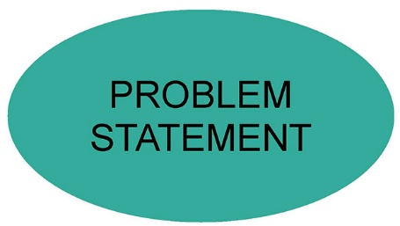
Enter problem statement:

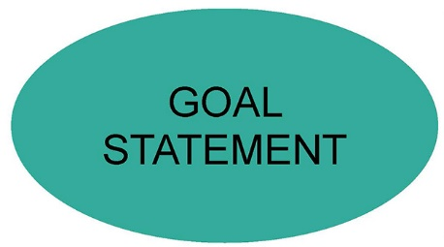
Enter goal statement:

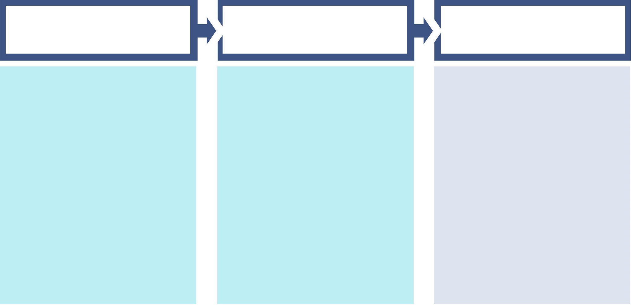
INPUTS | ACTIVITIES/  OUTPUTS | OUTCOMES

Activity 4: Closing Self-Reflection
Purpose: This exercise can help you formulate the reasons you might undertake a program evaluation and what you will do with the information you uncover.
Directions: Answer the following questions in the space provided:
- What is the impact on student outcomes?
- What will you do if you learn your program is/is not having an impact on student outcomes?

Facilitator note: If doing this activity with a group, consider making this a 10-minute think-pair-share, with the individuals working taking 5 minutes to brainstorm and 5 minutes to share with another person. This can help to identify the differing contexts in which program evaluation might be applied.
Facilitator note: If doing this activity with a group, consider making this a 10-minute think-pair-share, with the individuals working taking 5 minutes to brainstorm and 5 minutes to share with another person. This can help you to consider areas in which you might wish to conduct a future evaluation of program impacts and with whom you might share your results.
Facilitator note: If doing this activity with a group, consider making this a 10-minute think-pair-share, with the individuals working taking 5 minutes to brainstorm and 5 minutes to share with another person. This can help to identify the differing contexts in which program evaluation might be applied.
Facilitator note: If doing this activity with a group, consider making this a 10-minute think-pair-share, with the individuals working taking 5 minutes to brainstorm and 5 minutes to share with another person.

